

Shopping Cart Sales Analysis
Prepared by: Ramsheena

Overview

This project focuses on analyzing a shopping cart / retail sales database using SQL. The goal is to understand sales performance, customer behavior, product demand, and delivery efficiency. The analysis helps businesses make data-driven decisions related to revenue growth, inventory planning, marketing, and operations.
The database consists of four main tables: customers, orders, products, and sales, which together represent an end-to-end e-commerce transaction flow.

Project Objectives
- Analyze overall sales performance and revenue
- Identify top-selling products and product types
- Understand customer purchasing behavior
- Analyze demographic factors such as age, gender, and location
- Evaluate delivery performance
- Provide actionable business insights and recommendations

Dataset Description & Objectives

Tables used:

1. customer6 – Stores customer demographic information
2. orders1 – Stores order-level information
3. products1 – Stores product details
4. sales1 – Stores transactional sales data

Dataset Objectives

The dataset is designed to simulate a real-world e-commerce system where:
- A customer places one or more orders
- Each order contains one or more products
- Sales data records quantities and revenue at product level

What’s Happening in the Data

1.Customers register and place orders
2.Orders store payment and delivery details
3.Each order generates multiple sales records
4.Products are sold in different sizes and colors
5.Revenue is generated at the sales level

Data Cleaning Steps
To ensure accurate analysis, the following data cleaning steps were applied:

- Removed missing and incomplete records
- Removed duplicate records
- Corrected and standardized data types
- Ensured consistent text formatting (trimmed spaces, standardized case)
- Validated and corrected date formats such as order_ date, delivery _ date
- Validated foreign key relationships between tables
- Handled null delivery dates
- Normalized data into structured tables to avoid duplication

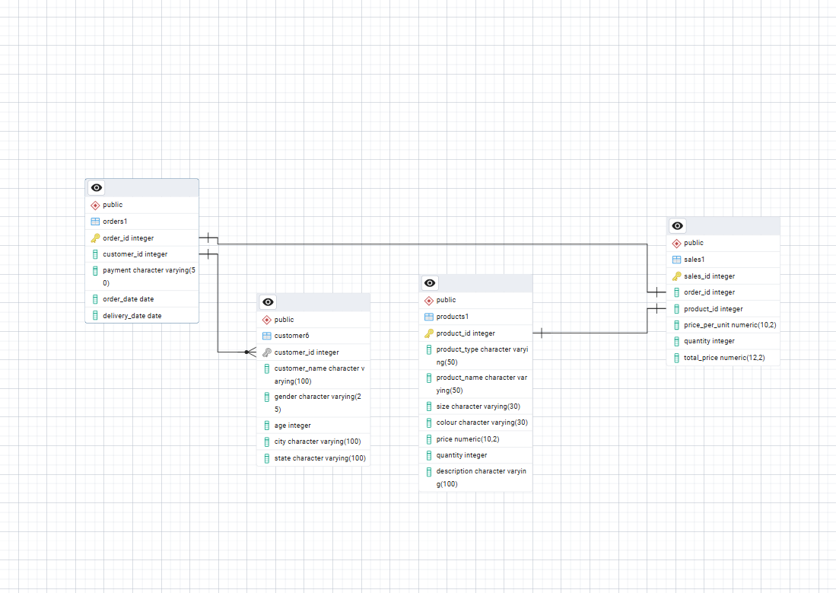

Basic Sales Exploration

1.Total Revenue
Syntax
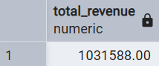

Insights:
- Total revenue represents the overall financial performance of the business for the given dataset period.
- It shows how much money the business earned from all completed sales, combining every product, order, and customer.
- This metric acts as a baseline KPI (Key Performance Indicator) against which all other analyses are compared.

What this tells the us;
- If total revenue is high, it indicates strong product demand and effective sales operations.
- If total revenue is low or declining, it signals issues such as Poor product performance, Low customer demand, Pricing or marketing problems

2. Products Selling Most (by Quantity)
Syntax
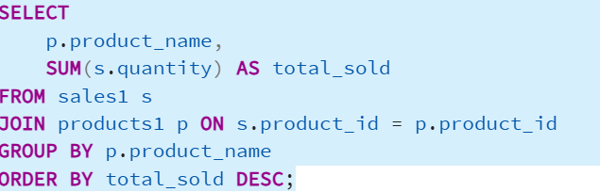

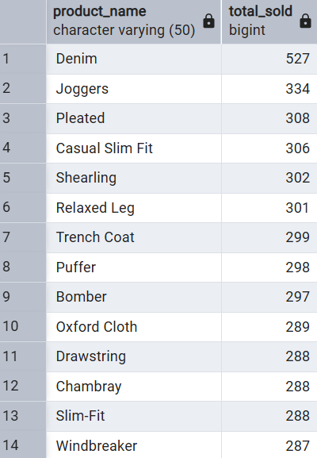
Insights:
- This query calculates the total quantity sold for each product.
- It identifies the most frequently purchased products based on sales volume.

- The data is grouped by product name and sorted from highest to lowest quantity sold.
- It helps highlight customer preferences and high-demand items.
- This metric focuses on sales volume rather than revenue value.

What this tells us;
- Identifies best-selling products that customers buy most often.
- Shows which products have high demand in the market.
- Helps the business understand customer preferences.

3. Product Types Generating Highest Revenue
Syntax
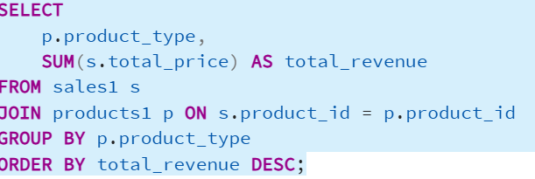

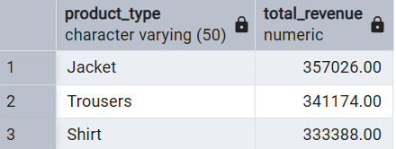

Insight:

Shows total revenue generated by each product type
Identifies which product categories contribute the most revenue
Highlights top-performing products based on sales value
Helps compare revenue contribution across product categories
Useful for business decisions like inventory planning and pricing strategy

What this tells us:

The analysis reveals which product types generate the highest revenue.
This helps identify high-performing categories, understand customer demand patterns, and focus on products that drive overall business profitability.

4. Top Customers by Spending
Syntax

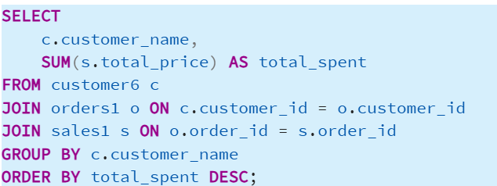

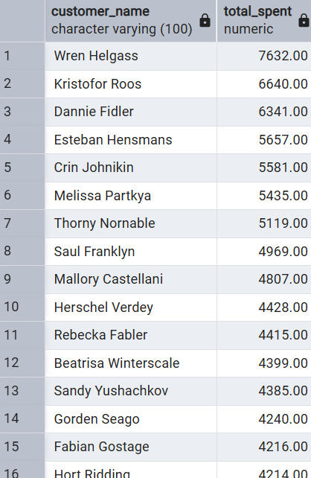

Insights:
- This query calculates the total amount spent by each customer.
- It joins customer, order, and sales tables to compute complete spending history.
- The data is grouped by customer name and sorted from highest to lowest spending.
- It identifies high-value customers based on total purchase amount.
- This metric helps measure customer contribution to overall revenue

What this tells us;
- Identifies high-value customers who contribute the most to revenue.
- Shows which customers are most important for business growth.
- Often, a small group of customers contributes a large portion of total revenue.

5. How Often Customers Buy
Syntax
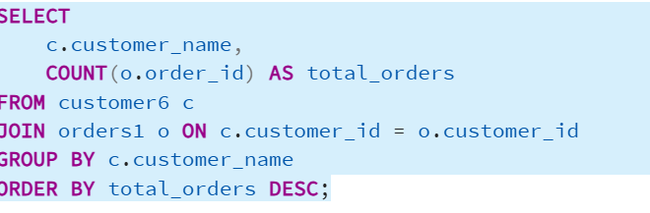

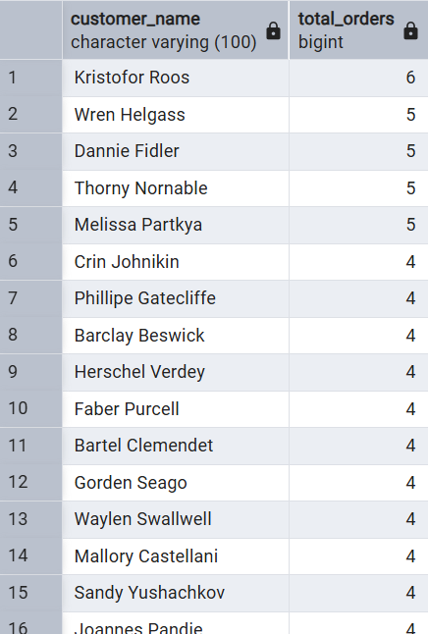

Insight
- This query calculates the number of orders placed by each customer.
- It counts how many times a customer appears in the orders table.
- Customers are ranked from most frequent buyers to least frequent buyers.

What this tells us;
- Identifies repeat customers who buy again and again.
- Shows the level of customer loyalty.
- Helps distinguish between:
  - Loyal customers (many orders)
  - One-time or occasional customers (few orders)

6. Sizes / Colors Selling Fast
Syntax
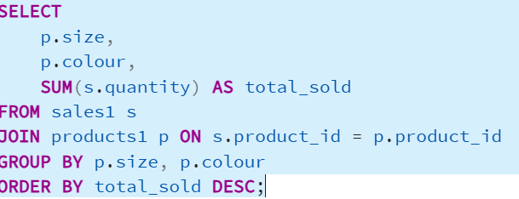

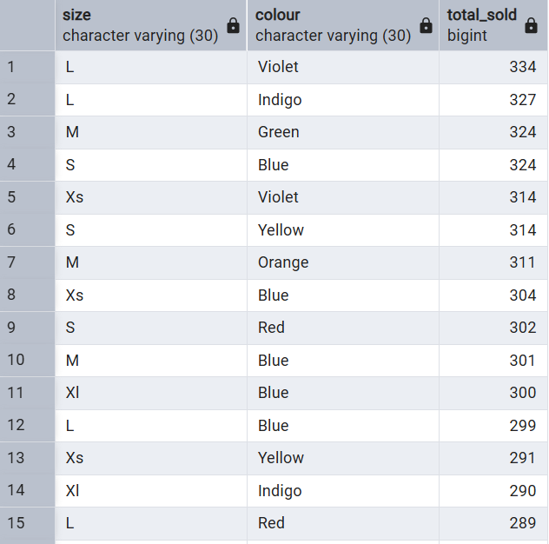

Insights:
- This query calculates the total quantity sold for each size and color combination.
- It identifies which size–color variants are selling the fastest based on sales volume.
- The data is grouped by colour and size. then sorted from highest to lowest quantity sold.
- It highlights customer preferences for specific product variations.
- This analysis focuses on demand patterns at the variant level rather than overall product level.

What this tells us;
- Identifies popular size–color combinations that customers buy frequently.
- Reveals customer preferences at a detailed variant level, not just at product or category level.
- Helps the business understand which product variations drive demand.

7. Age Group Buying More
Syntax
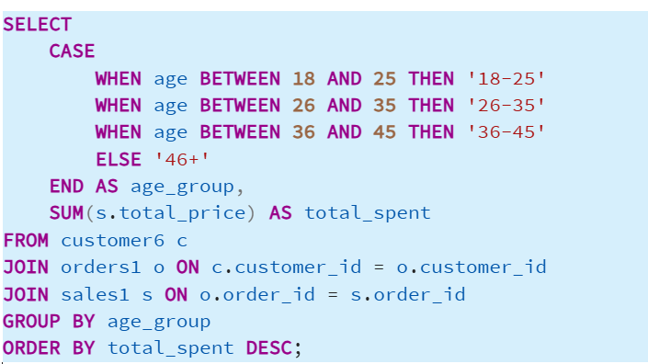

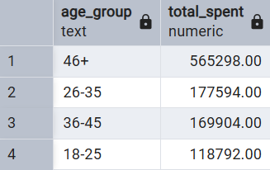

Insight
- This query groups customers into age categories based on their age.
- It then calculates the total amount of money spent by each age group.
- The result shows which age group contributes the highest revenue.
What this tells us;
- Identifies the strongest age-based customer segment.
- Shows which age group is most engaged in purchasing and spending.
- Helps understand customer behavior patterns across different age ranges.

8. Sales by Gender
syntax
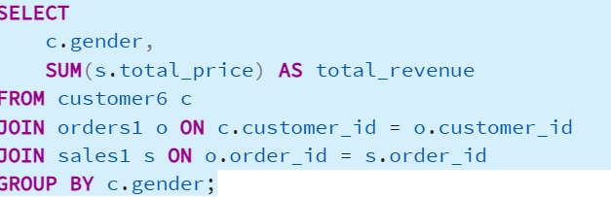
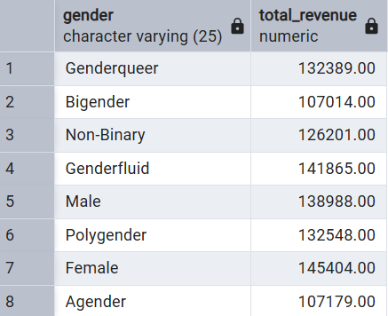

Insight
- This query calculates the total revenue generated by each gender.
- The results show how much each gender contributes to overall sales.

What this tells us;
- Identifies which gender group contributes more revenue.
- Helps understand gender-based purchasing behavior.
- Reveals whether sales are balanced across genders or dominated by a specific group.

9. Sales by State
Syntax
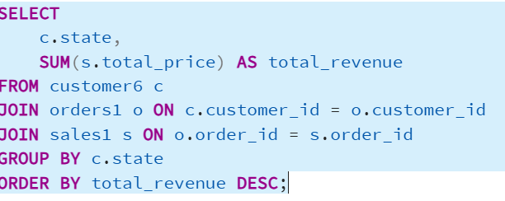

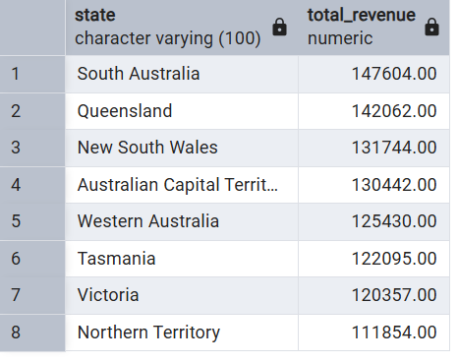

Insight
- This query calculates the total revenue generated from each state.
- Results are grouped by state and sorted from highest to lowest revenue.

What this tells us;
- Identifies high-revenue regions where the business performs best.
- Shows geographical differences in customer demand and spending power.
- Helps understand where the majority of sales are coming from.

10. Delayed Deliveries

Syntax
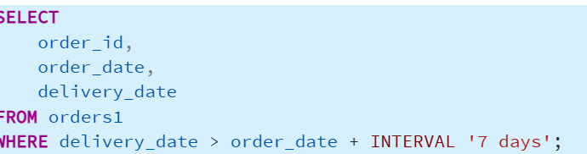

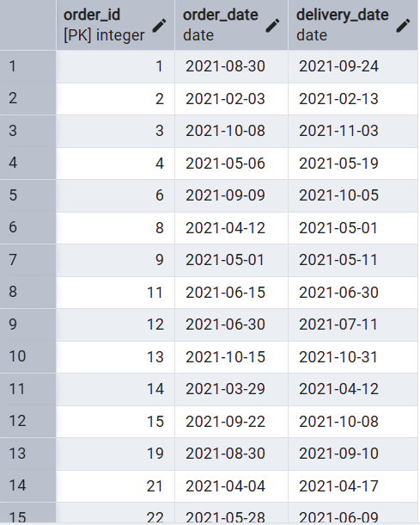
Insight
- This query identifies orders that took more than 7 days to be delivered.
- If the delivery date is more than 7 days after the order date, the order is marked as delayed.

What this tells us;
- Highlights delivery delays in the order fulfillment process.
- Shows which orders did not meet the expected delivery timeline.
- Helps identify logistics, supply chain, or courier issues.

11. Average Delivery Days
Syntax
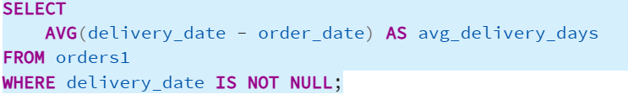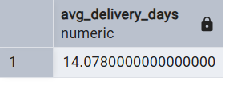
Insight
- This query calculates the average number of days taken to deliver orders.
- The result of delivery _date, order _date gives delivery time in days for each order.
- AVG () computes the average delivery duration across all delivered orders.
- WHERE delivery _date IS NOT NULL ensures that:
  - Only completed deliveries are considered
  - Undelivered or cancelled orders do not affect the result

What this tells us;
- Shows overall delivery performance of the company.
- Provides a single, easy-to-track metric for logistics efficiency.
- Helps measure whether delivery timelines meet business expectations.

12. Common Payment Amounts
Syntax

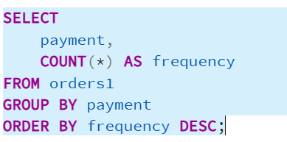

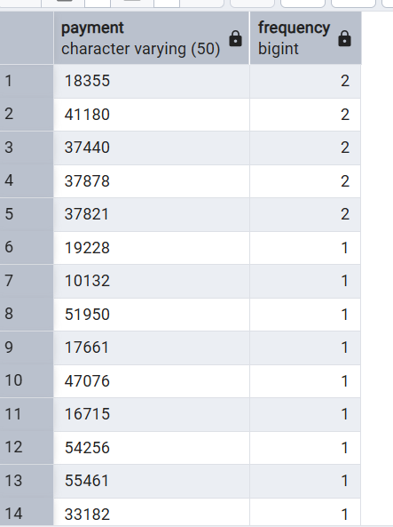
Insight
- This query identifies which payment amounts are most common in the orders table.
- Some payment amount appear more than once, indicating:
  - These could be popular order sizes
  - Or common price bundles/products
- Most payment values appear only once, suggesting:
- Customers often place customized or varied orders
- No strict standard pricing pattern

What this tells us;
- Shows typical order values customers pay.
- Helps understand customer spending patterns.
- Reveals whether customers usually:
  - Make small purchases
  - Medium-sized orders
  - High-value purchases

13. Total Number of Orders
Syntax
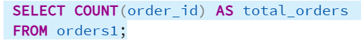
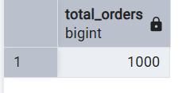
Insight
- The total number of orders shows overall customer activity and demand level.
- A high order count means that Strong customer interest good market reach, Effective sales or marketing efforts
- A low order count may indicate Low customer engagement, Seasonal slowdown, Need for better promotions or visibility

What this tells us:
- Indicates overall demand for products.
- Reflects how active customers are in placing orders.
- Helps understand whether the business is receiving high or low order volume.

14. Customer Purchase Count
Syntax
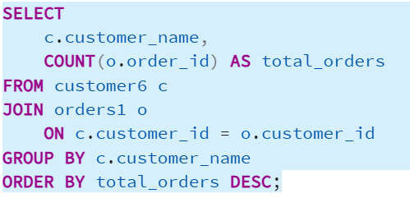

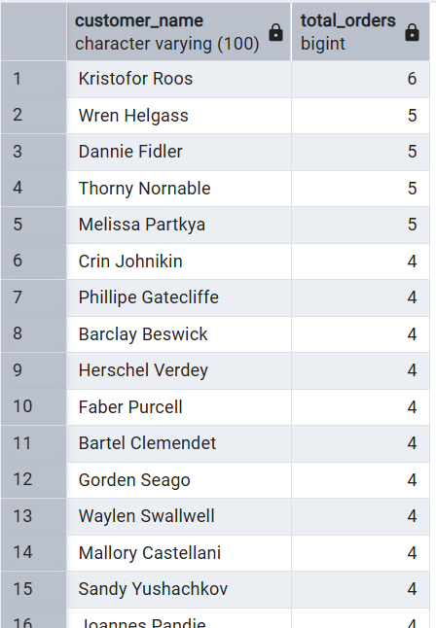

Insight
- This analysis helps identify frequent buyers who purchase repeatedly from the business.
- Customers with a high order count show the Strong brand loyalty, High trust in products and services, Consistent purchasing behavior.

- Customers with a low order count may be new customers, Occasional buyers, at risk of not returning.

What is this tell us;
- If many customers have high order counts, the business has strong customer retention.
- If most customers place only one order, it indicates:
  - Low repeat purchase rate
  - Need for better engagement or loyalty strategies

Overall Insights and Recommendations

Overall Insights
- A small percentage of products contribute a large share of revenue (Pareto effect)
- Certain product types consistently outperform others
- Repeat customers significantly increase total revenue
- Age groups 26–35 and 36–45 are strong revenue contributors
- Sales are concentrated in specific states and regions
- Delivery delays beyond 7 days negatively impact customer experience

Recommendations
- Focus marketing and loyalty programs on top-spending and repeat customers
- Maintain higher inventory levels for fast-selling products, sizes, and colors
- Expand marketing campaigns in high-revenue states and regions
- Improve logistics and fulfillment processes to reduce delayed deliveries
- Personalize offers based on age group and purchase behavior
- Monitor underperforming product types and consider optimization or removal

